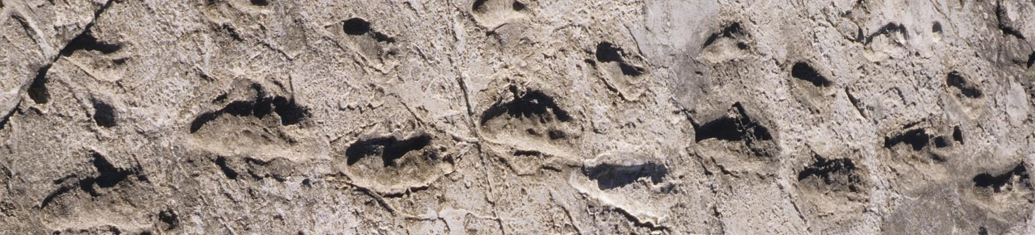
Figure 1. Laetoli footprint
Laetoli is a site in Tanzania, dated to the Plio-Pleistocene and famous for its hominin footprints, preserved in volcanic ash. Dated to 3.7 million years ago, they were the oldest known evidence of hominin bipedalism at that time. Subsequently, older Ardipithecus ramidus fossils were found with features that suggest bipedalism.

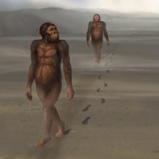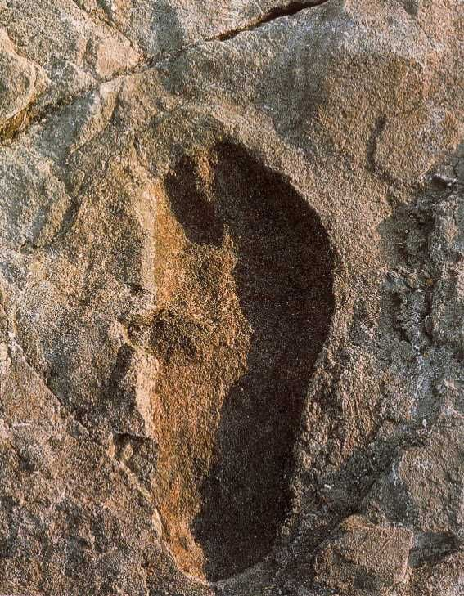

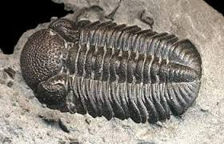
Figure 2. Trilobite
Trilobites disappeared in the mass extinction at the end of the Permian about 252 million years ago. By the time trilobites first appeared in the fossil record, they were already highly diversified and geographically dispersed. Because trilobites had wide diversity and an easily fossilized exoskeleton, they left an extensive fossil record.

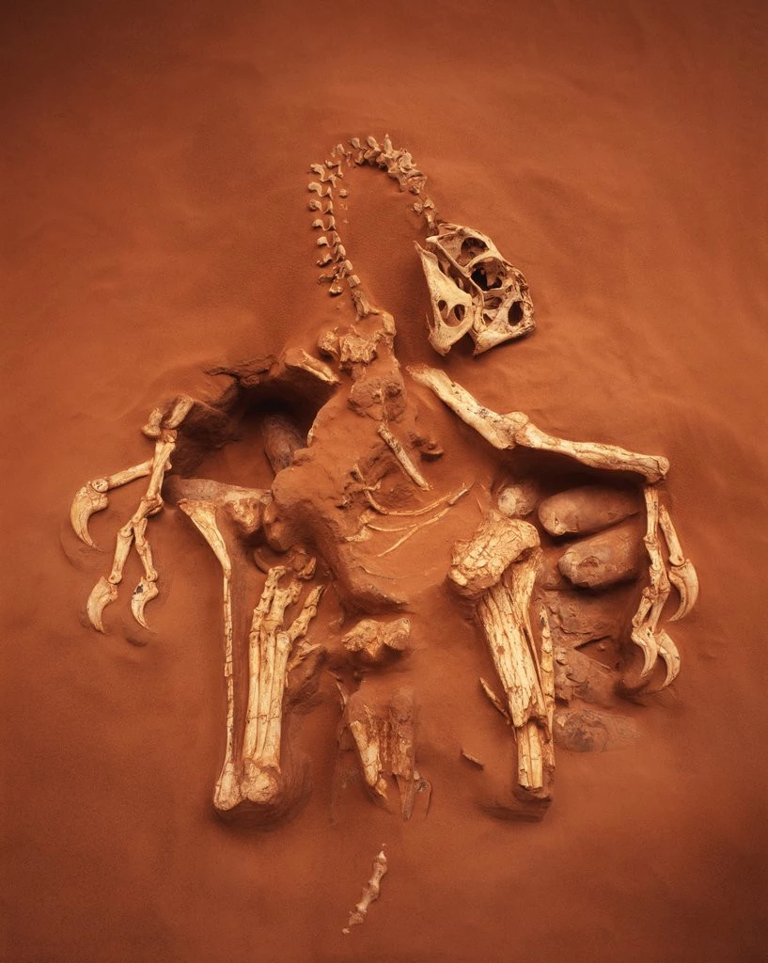
Figure 3. Oviraptor
Oviraptor lived in the late Cretaceous period, during the late Campanian stage about 75 million years ago. This is an image of the Oviraptor protecting its nest of eggs.

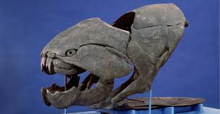
Figure 4. Jawed-Fish Dunkleosteus
that existed during the Late Devonian period, about 358–382 million years ago. The name Dunkleosteus combines the Greek osteon, meaning "bone", and Dunkle, in honor of David Dunkle of the Cleveland Museum of Natural History. The largest species, D. terrelli grew up to 6 m (19.7 ft) long and 1 t (1.1 short tons) in weight. Few other placoderms rivaled Dunkleosteus in size.

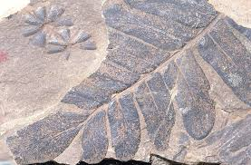
Figure 5. First Vascular plants
The first vascular plants Ferns first appear in the fossil record about 360 million years ago in the late Devonian period.

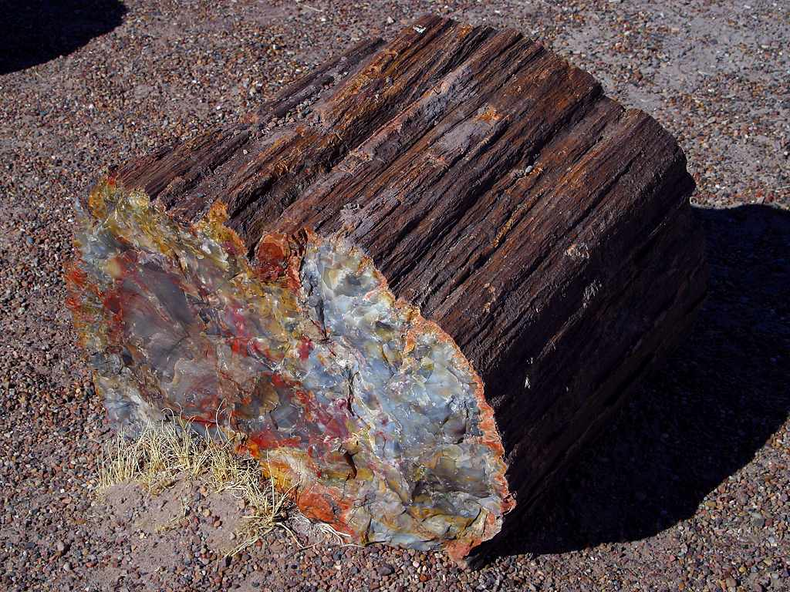
Figure 6. Petrified Redwood Tree.
The earliest redwoods showed up on Earth shortly after the dinosaurs – and before flowers, birds, spiders… and, of course, humans. Redwoods have been around for about 240 million years.

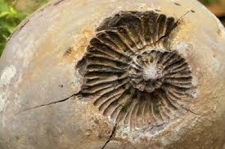
Figure 7. Ammonite fossil.
Ammonites are excellent index fossils, and it is often possible to link the rock layer in which a particular species or genus is found to specific geologic time periods. This particular genus was around during the upper cretaceous around 130mya.
Originating from within the bactritoid nautiloids, the ammonoid cephalopods first appeared in the Devonian (circa 409 million years ago) and virtually became extinct at the close of the Cretaceous (66 Mya) along with the dinosaurs.

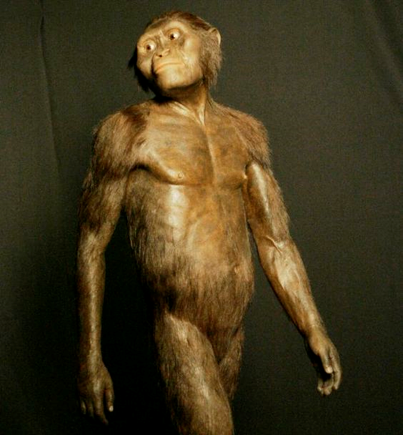
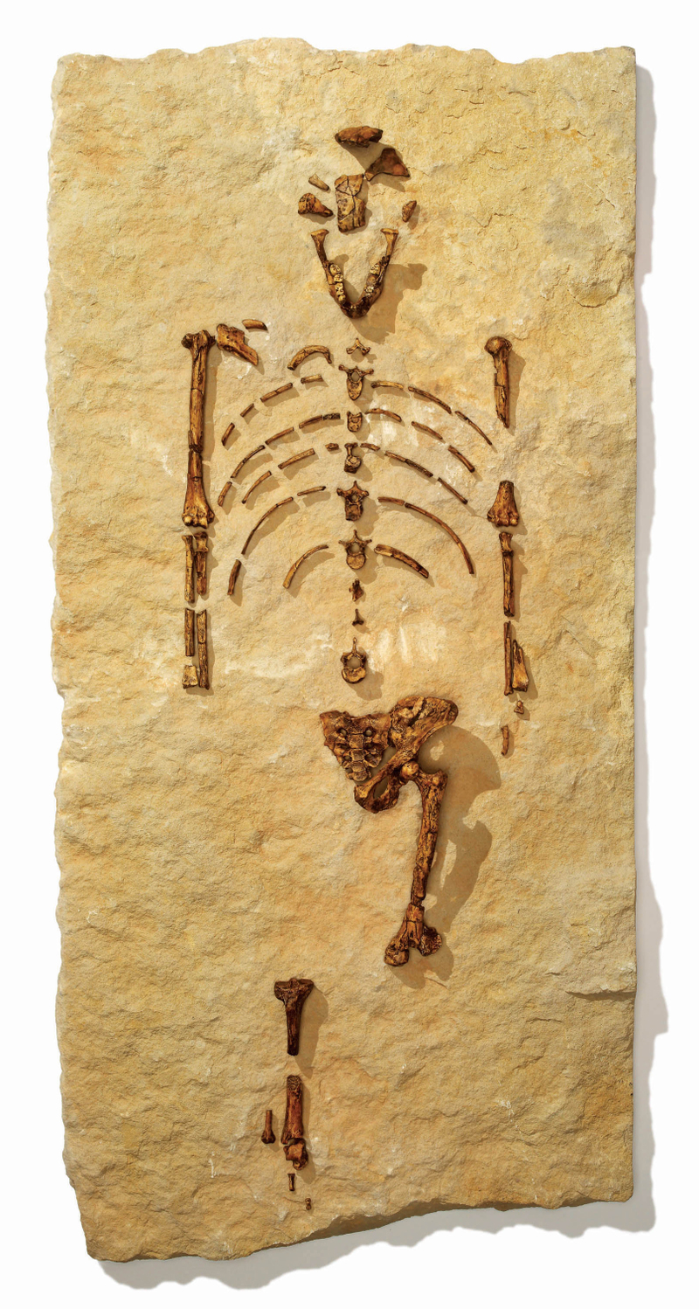
Figure 8 Lucy Fossil Australopithecus afarensis.
Lucy is the common name of AL 288-1, several hundred pieces of bone fossils representing 40 percent of the skeleton of a female of the hominin species Australopithecus afarensis. The Lucy specimen is an early australopithecine and is dated to about 3.2 million years ago. The skeleton presents a small skull akin to that of non-hominin apes, plus evidence of a walking-gait that was bipedal and upright, akin to that of humans

